29.31: a)
(b) For a conservative field, the work done for a closed path would be zero.
(c) 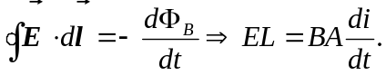 A is the area of the solenoid.
For a circular path:
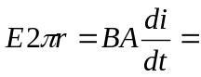constant for all circular paths that enclose the solenoid.
So 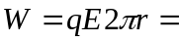constant for all paths outside the solenoid.
